**VEHICLE THEFT ANALYSIS**

**PROBLEM STATEMENET:**

The analysis makes use of fixed datasets to produce results. The data may vary regularly. Hence day-today updated results are not visualized to the users. Our proposed system reduces the disadvantage by manually updating the database and producing updated visualized data to the users. There is a shortage of research especially on the reclamation of stolen motor vehicles. The system also seeks to expand the understanding of the role of insurance fraud

**REQUIREMENTS:**

* Jupyter Note Book
* Data set

**EXISTING SYSTEM:**

In the existing system the analysis performed are not accurate. There are separate analysis performed for vehicle theft, insurance claims and for fraud analysis. The disadvantage of the existing application is there more missing data. The datasets are not updated continuously. Hence the analysis visualized to the users is not accurate. The analysis is published only in a documentation method and not in a visualized report. The analysis performed is not visualized to the users. In the existing system, updation of the data in the dataset is not made for obtaining accurate result. The dataset is permanent and no changes are made to the data. The time consumed for performing the analysis is also high. The data are collected by conducting survey or online.

### DRAWBACKS

* It takes very long time to complete the process
* The analysis is approximate but not accurate.
* The analyses for theft, insurance claims and fraud analysis are separate.

# PROPOSED SYSTEM

In our proposed system the analysis provided are more accurate. The datasets are requested from the insurance agencies to perform the analysis. The analysis for vehicle theft, insurance claims and fraud analysis are performed under single application. The datasets are updated with new data with regular intervals to obtain accurate result. The regions where the motor vehicle theft is high and agents under whom the false insurance claims are made is analyzed and can be visualized using Tableau. The time consumed for performing the analysis is very less.

### ADVANTAGES

* + Data provided after analysis is accurate.
  + All data are made available in single analysis
  + The regions where the vehicle theft is high are analyzed and listed.
  + Whereas in this application current updates are possible.

### ALGORITHMS

* KMeans
* Linear Regression

### KMeans ALGORITHM

We make use of two sim cards each for sender and receiver kit to transmit and receive data. Using the sender kit we send the user information to the receiver kit through GSM modem. All the details and reports of the customer information are sending to the server and stored in the data base. The entire transactions is through those two sim cards there is no unauthorized users to hack the details hence the customer information’s are more secure

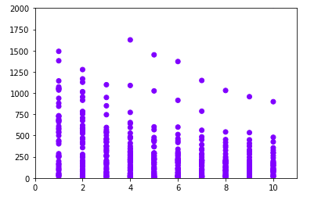

**LINEAR REGRESSION ALGORITHM**

Linear regression is an algorithm which explains the abstraction between a dependent variable and an independent variable. If the regression algorithm deals with one independent variable, then it is a simple linear regression algorithm. If it deals with two or more independent variable, then it is multiple linear regression algorithms. The linear regression maybe applied in areas which require prediction, forecasting or error reduction. This algorithm also defines the relationship between the dependent and independent variables. The expression for linear regression is

Y = a+bX

where X is an independent variable and Y is the independent variable. The slope of line is b and a is the intercept.

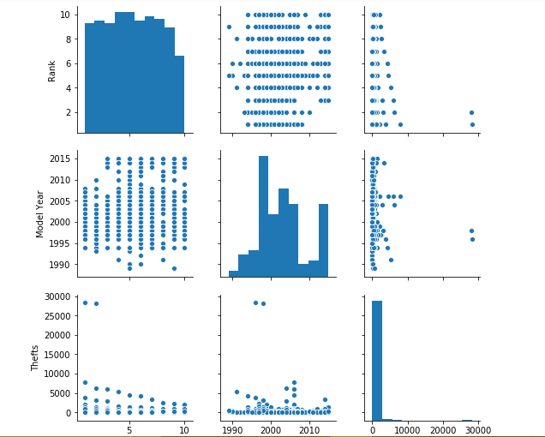

### Some special features of this project are

* It reduces the manpower to some extent.
* It reduces the time complexity.
* It avoids redundancy of data and also system supports for taking the floppy backups of front end for future enhancements

### FUTURE ENHANCEMENTS

We have proposed an efficient financial system in which the transactions are sim based and the details of customer are securely saved both in system server and web server.

Our project may be enhanced in future by implementing the satellite for an individual organization. So, the speed of transaction through satellite will be very fast.

### CONCLUSION

We have proposed an efficient financial system transactions based on sim cards. The details of customer which are registered are saved in the system server and web server in the secured manner. The confidentiality in our project is, unauthorized users cannot hack the transactions. Since the transactions are sim based, it is limited within an individual organization.